**EXPERIMENT 02**

**Title: 2. To understand and apply the concept of Constraints**

1. Create the tables described below:

**Table name: CLIENT_MASTER_1**

use exp2;

CREATE TABLE CLIENT_MASTER(

CLIENT_NO VARCHAR(6),

NAME VARCHAR (20) ,

ADDRESS1 VARCHAR(30),

ADDRESS2 VARCHAR(30),

CITY VARCHAR(15),

PINCODE int,

STATE VARCHAR(15),

BAL_DUE DECIMAL(10,2));

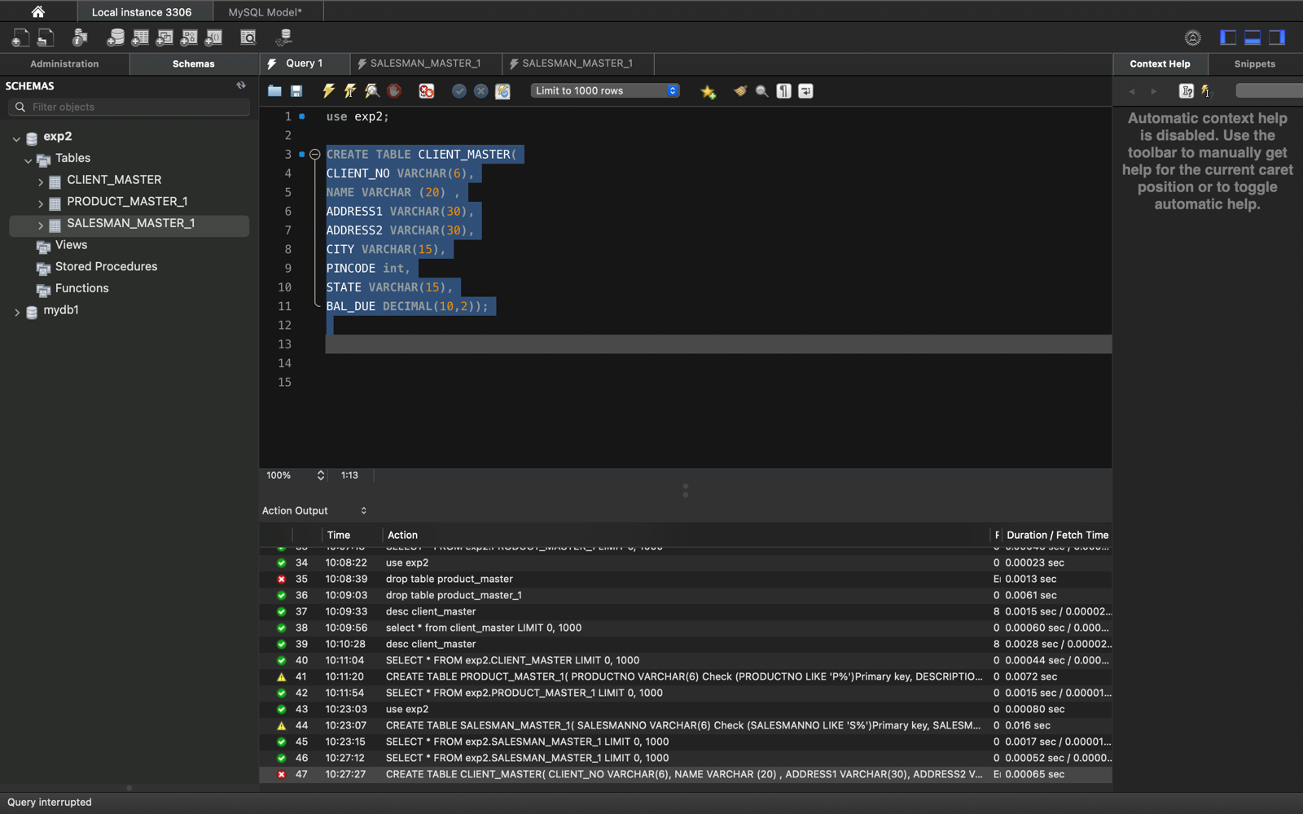

**Table Name: PRODUCT_MASTER_1**

CREATE TABLE PRODUCT_MASTER_1(

PRODUCTNO VARCHAR(6) Check (PRODUCTNO LIKE 'P%')Primary key,

DESCRIPTION VARCHAR (15) Not Null,

PROFITPERCENT DECIMAL(4,2) Not Null,

UNITMEASURE VARCHAR(10) Not Null,

QTYONHAND INTEGER(8) Not Null,

REORDERLVL INTEGER(8) Not Null,

SELLPRICE INTEGER(8)Not Null,

COSTPRICE INTEGER(8)Not Null)

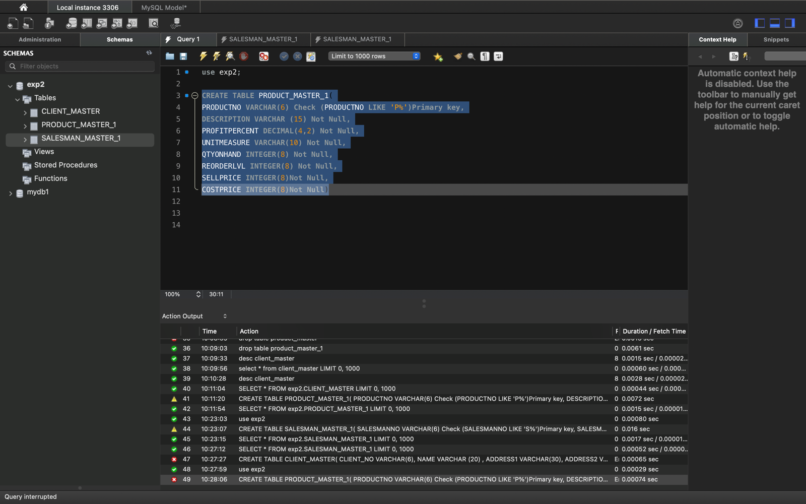

**Table Name: SALESMAN_MASTER _1**

CREATE TABLE SALESMAN_MASTER_1(

SALESMANNO VARCHAR(6) Check (SALESMANNO LIKE 'S%')Primary key,

SALESMANNAME VARCHAR (20) Not Null,

ADDRESS1 VARCHAR (30) Not Null,

ADDRESS2 VARCHAR (30) Not Null,

CITY VARCHAR (20) Not Null,

PINCODE INTEGER(8) Not Null,

STATE VARCHAR (20) Not Null,

SALAMT REAL(8,2) Not Null check(SALAMT !=0),

TGTTOGET DECIMAL (8,2) Not Null check(TGTTOGET !=0),

YTDSALES DECIMAL (8,2) Not Null,

REMARKS VARCHAR (60))

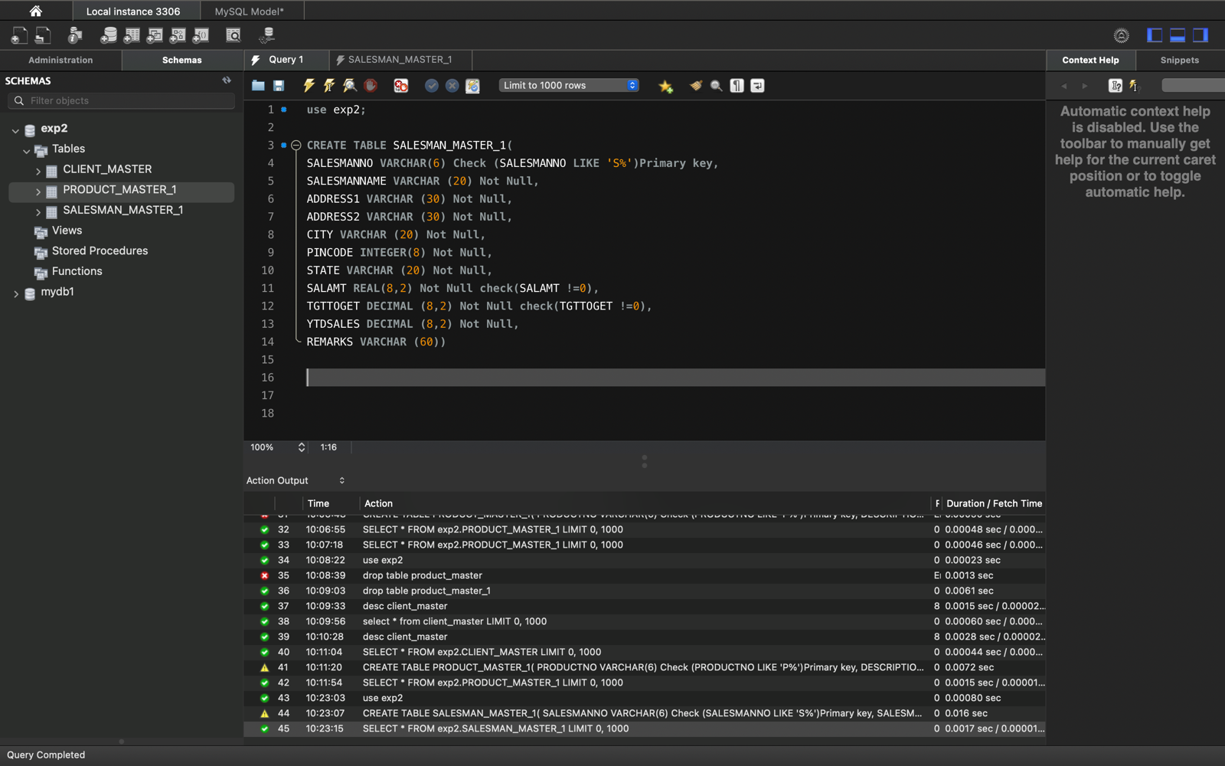

**2. Insert the data in these two tables.**

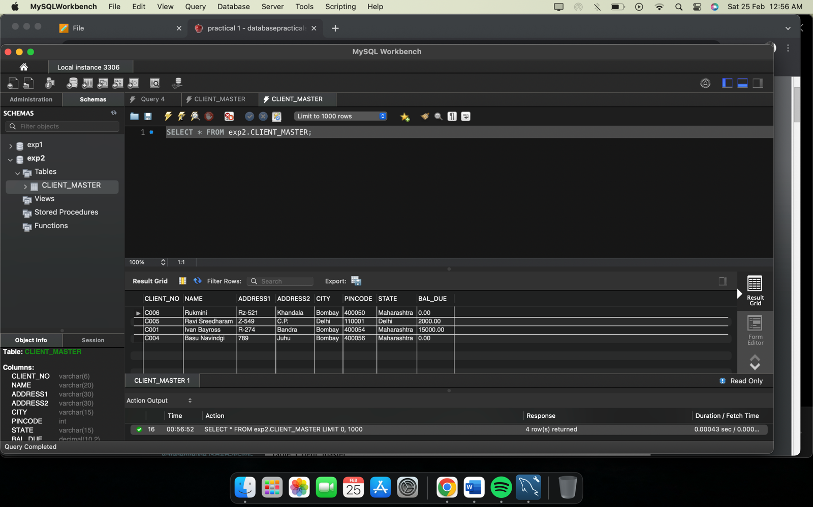

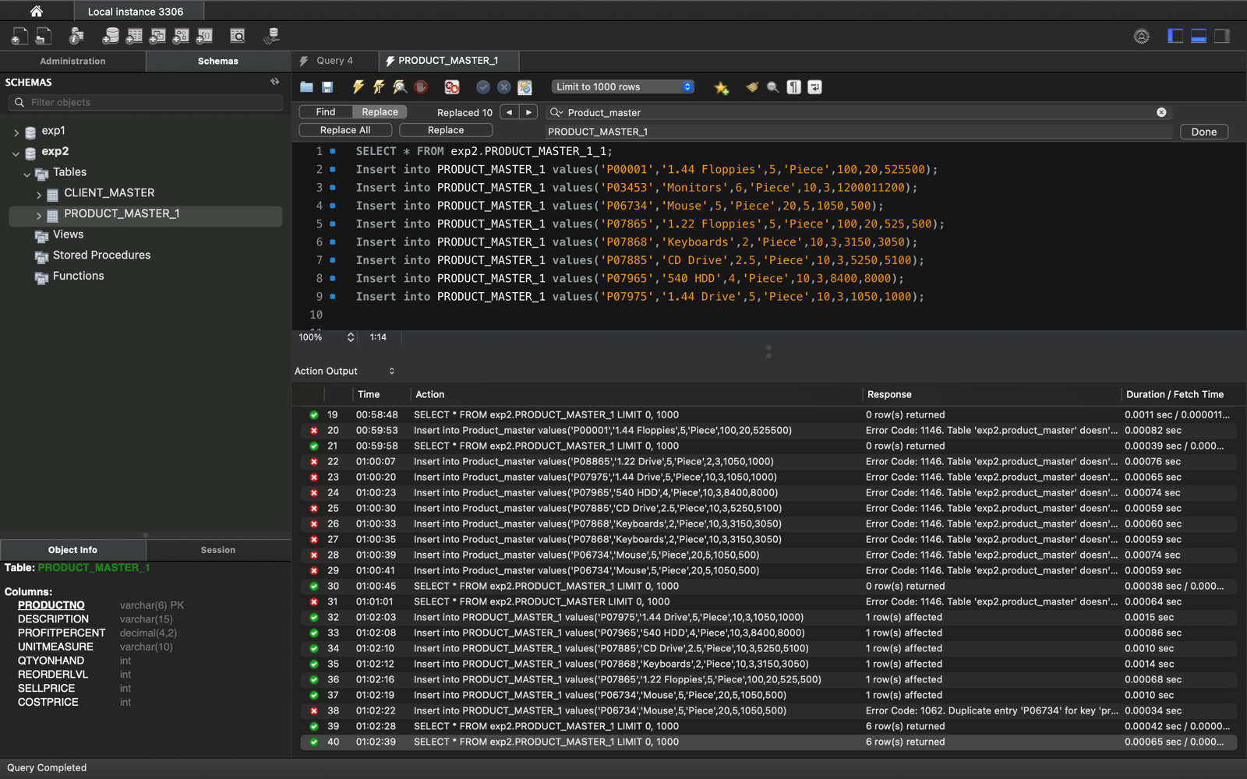

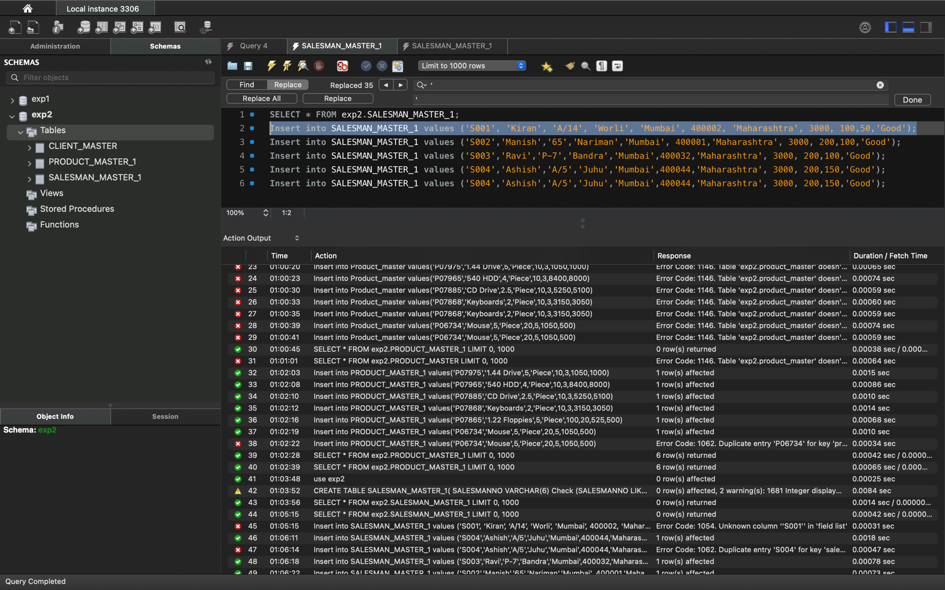

**4. Create table AUTHOR**

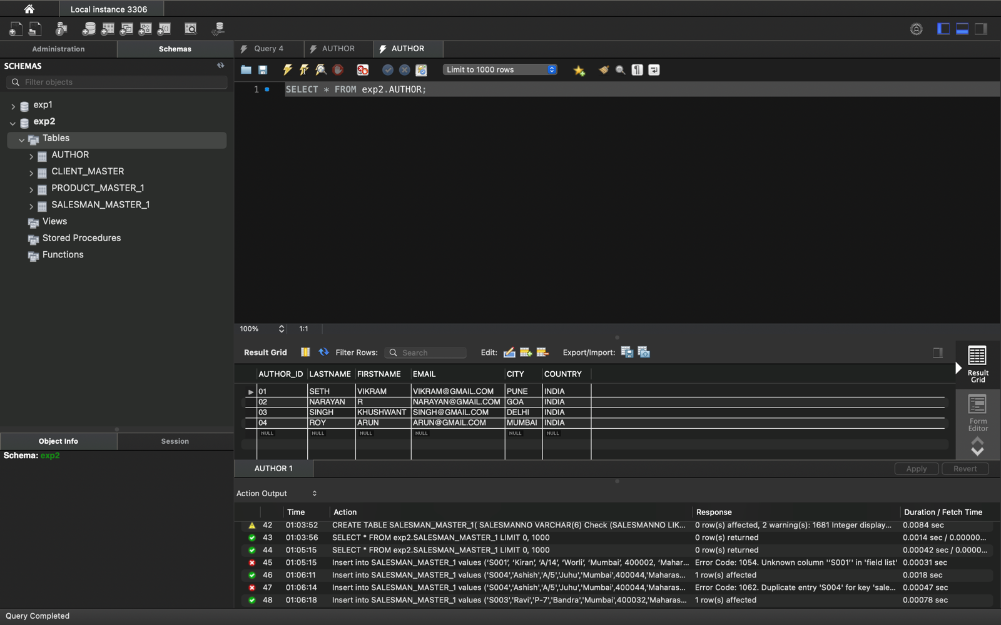

**5. Create Table BOOK={ Book_ID, Book_Title, Copies)**

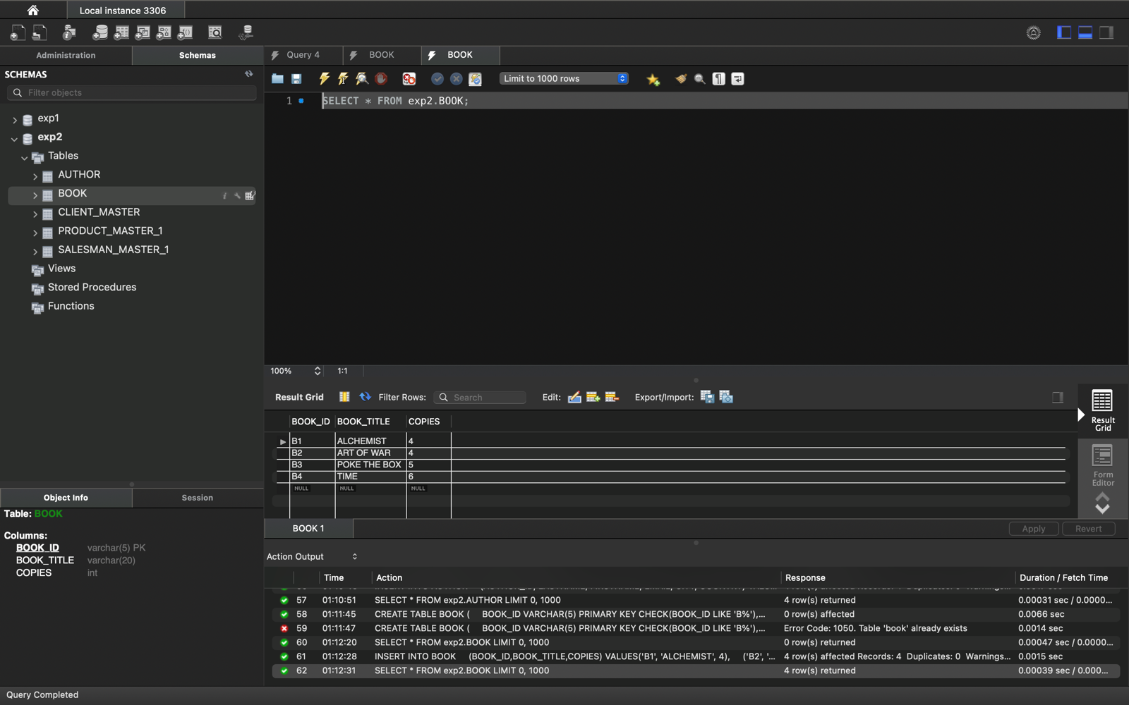

**6. Create table AUTHOR_LIST = {Author_ID , Book_ID , Role}**

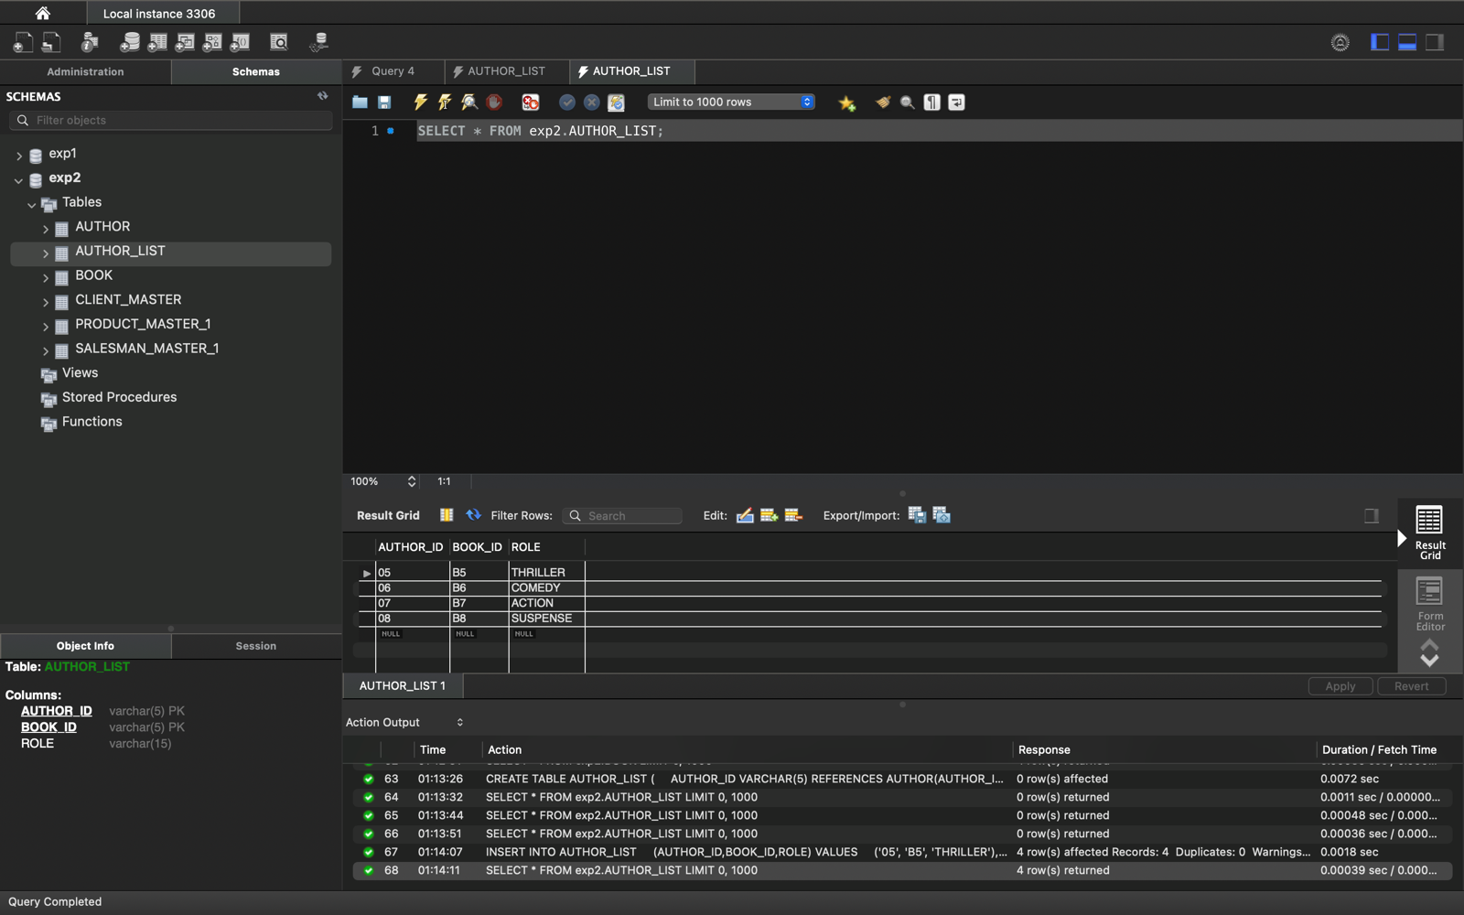

**7- Adding records to all these 3 tables created .**

**8- Alter structure of table AUTHOR_LIST add the field Publisher data type of**

**30Character.**

